Green Society Public School
D-
Ratnanagar-7, Sauraha, Chitwan
Annual Examination-2082
Class: Nursery Time: - 2 hrs. F.M.: 50
Sub: English ‘W’
Name: Roll No.: Sec.:
________________ ______________ OBT.MARKS:
INVIGILATOR EXAMINER

1. Match the letters with the correct pictures. [5]
B


K

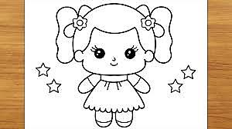
L

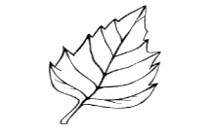
D

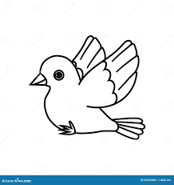
G


P

2. Colour the capital letters. [5]
M m b T
a r Q i l
A e n Z

3. Copy the same letters. [6]
a b c d e f
_____ _____ _____ _____ _____ _____
4. Match the same capital letters with small letters. [5]
F j
J f
O z
S o
Z s

5. Circle the same letters. [5]
Aa- Aa Bb Cc
Ee- Ff Ee Gg
kk- Jj Ii kk
Pp- Pp Oo Qq
Ww- Tt Ww Uu
6. Copy down the words. [6]
Ant Bus Cat

7. Write the missing letters. [12]
A D F G J
k M N P Q R
U W Y ___


8. Colour the picture. [5]

The End

